LAB REPORT # 03


Submitted by:

Submitted by:

Name | Registration No.
Muhammad Abdullah | FA24-BSE-042
Submitted to: Sir Raheel Ahmed
Course Code: EEE240
Dated: March 1 , 2026.

DEPARTMENT OF COMPUTER SCIENCE
COMSATS UNIVERSITY ISLAMABAD,
ISLAMABAD CAMPUS

Boolean Function Implementation using Universal Gates

In-Lab Tasks-Part-1:

Lab-3 task, F(a,b,c,d) = Σm(0,1,2,3,8,10,15)
Expanded SOP:
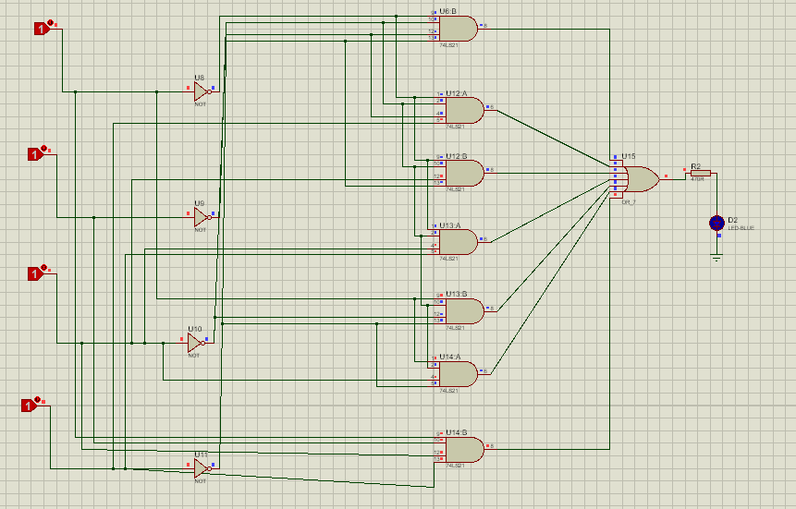
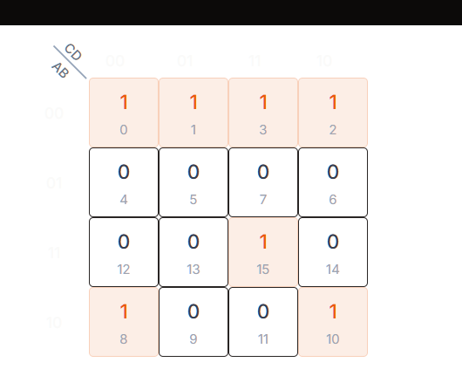
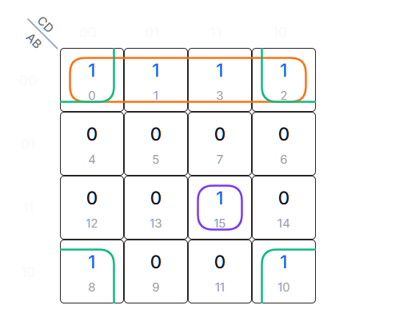

Simplified Boolean Expression
A'B'+ABCD+B'D'
